HCI Robot Assignment User Guide by Stephen Davison

Contents:

- Application map
- Introduction
- Simple worked example
- Troubleshooting / common problems.

Application Map:

This is the robot controller application program that you have:

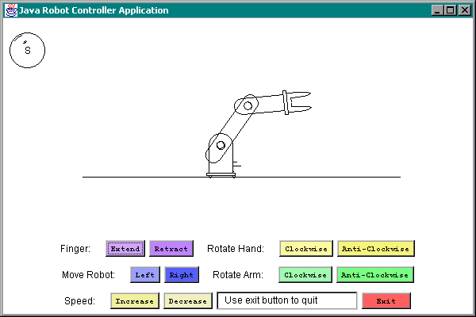

Key Features:

- The speedometer. The object in the top left is the speedometer that will give you an idea of how much you are going to move the robot part.

For example:
This speedometer shows a speed that will move an object very little:
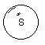This speedometer shows a speed that will move an object a lot:
- 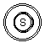The robot: This is a representation of what you are controlling.
Example:
- 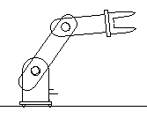Coloured buttons: These buttons do what it says them, according to what the label says. For example:
Clicking the Anti-Clockwise will Rotate the arm anti-clockwise.

A note about speed:
The fingers have a restriction on how much they can be extended and retracted, so be sure to lower the speed to minimum before you use them, or you will see a message telling you that you cannot retract or extend the fingers any more. There are also restrictions that stops parts of the robot moving in certain directions, the restrictions are: +/- 250 units for the robot body, +/- 330 degrees for the arm and the hand, and +/- 5 units for the fingers.

- The friendly Nav text bar: This bar will remind you what you last did and it will also give you any errors: For example:
Is an indication that you have reached the speed limit.

e) The Big Red Exit button: This button does exactly what it says, its big, its red, and it exits you from the application.
Example:

Introduction:

This application is designed to be an easy to use representation of a robot controller. If something doesn’t work at first, don’t panic! There is nothing you can do to the program to make it crash. Relax. Think about what you want to do, and press the appropriate button. Check the speedometer, and see what the Nav bar says. Have some fun and experiment! You can also follow the simple worked example in the next chapter to get a feel of what to do and what will get you the results you want. Enjoy!

Simple Worked example:

This example assumes that you have only just loaded up the Java Robot Controller Application and that your screen looks something like this:

The first thing to do is to extend the fingers. Press the purple “extend” button until the Nav text bar says you cannot extend the fingers any more. The Fingers should now be wide open. Now, move the hand Clockwise a couple of times by pressing the yellow “Clockwise” button. Increase the speed by pressing the yellow “Increase” button until the Nav bar says you have reached the speed limit, and watch the speedometer. Now try rotating the hand Clockwise again. The hand should move in much greater steps now. Now try rotating the Arm Anti-Clockwise until the arm is on the left hand side of the robot body. Try pressing the finger retract button. The Nav bar should now say that you cannot retract the fingers any more. This is because the speed is far too high. Decrease the speed until you reach the limit, then try retracting the fingers again. The Nav bar should say that you can this time. Now increase the speed and move the robot left as 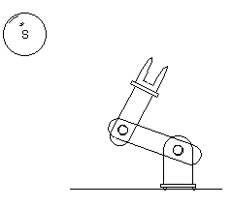much as you like. Now decrease the speed to minimum.
You should now have a robot in this position, Congratulations!!!

Troubleshooting / common problems:

Q. I cannot rotate/move/change the arm/body/hand/finger/speed any more.
A. It has either reached its limit or your speed is set too high. Look at the speedometer.

Q.I cannot exit the program.
A. Try the exit button again or close the window like a normal program.

